Lab#01

**Objective: Introduction to Sockets.**

**Task1:** Modify the sample code so that the sender uses the same socket to send the same message to two different receivers. Start the two receivers first, then the sender. Does each receiver receive the message? Capture the code and output. Describe the outcome.

Sending 1st msg to IP “10.11.4.158”: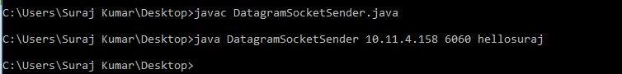

Received By IP “10.11.4.58”:

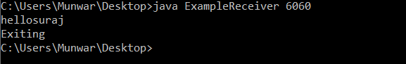

Sending 2nd msg to IP “10.11.0.231”:

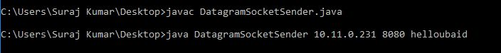

Received by IP “10.11.0.231”:

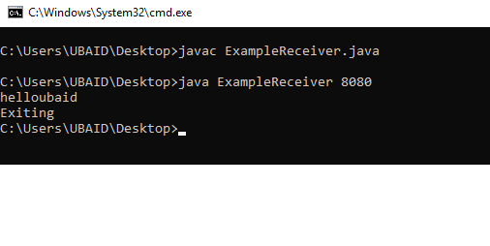

Task2: Modify the sample code so that the receiver loops five times to repeatedly receive then display the data received. Recompile. Then  
i. start the receiver

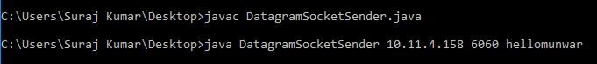

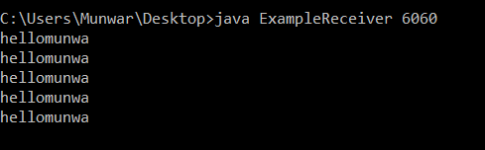  
ii. Execute the sender, sending a message “message1”, and  
iii. In another window, start another instance of the sender, sending a message “message2”. Does the receiver receive both the messages? Capture the code and output.

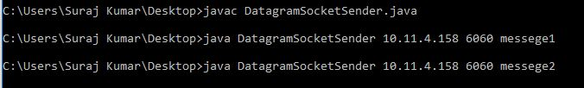

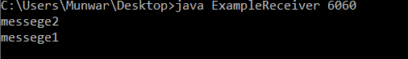

**Task3:**Modify the sample code to cater to a two way communication i.e. Sender sends a message to the Receiver, the Receiver receives the message and sends a reply to the Sender in return.

**Client Side Chat Code:**

import java.io.*;

import java.net.*;

class UDPClient{

public static void main(String args[])throws Exception{

byte[] sendData = new byte[1024];

byte[] receiveData = new byte[1024];

while(true){

BufferedReader inFromUser =new BufferedReader(new InputStreamReader(System.in));

System.out.print("Client:");

DatagramSocket clientSocket = new DatagramSocket();

InetAddress IPAddress = InetAddress.getByName("localhost");

String sentence = inFromUser.readLine();

sendData = sentence.getBytes();

DatagramPacket sendPacket = new DatagramPacket(sendData, sendData.length, IPAddress, 9876);

clientSocket.send(sendPacket);

DatagramPacket receivePacket = new DatagramPacket(receiveData, receiveData.length);

clientSocket.receive(receivePacket);

String modifiedSentence = new String(receivePacket.getData());

System.out.println("Server:" + modifiedSentence);

modifiedSentence="";

clientSocket.close();

}

}

}

**ClientSide Chat:**

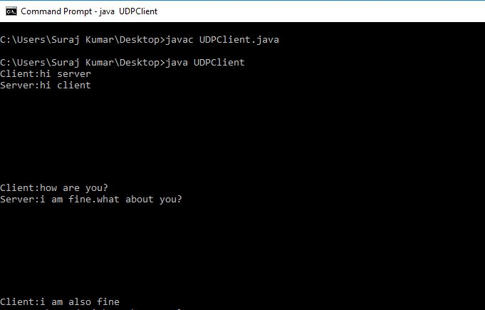

**Server side chat code:**

import java.io.*;

import java.net.*;

class UDPServer{

public static void main(String args[])throws Exception{

DatagramSocket serverSocket = new DatagramSocket(9876);

byte[] receiveData = new byte[1024];

byte[] sendData = new byte[1024];

while(true)

{

DatagramPacket receivePacket = new DatagramPacket(receiveData, receiveData.length);

serverSocket.receive(receivePacket);

String recieved = new String( receivePacket.getData());

System.out.println("Client: " + recieved);

BufferedReader inFromUser =new BufferedReader(new InputStreamReader(System.in));

System.out.print("Server:");

String sentence = inFromUser.readLine();

InetAddress IPAddress = receivePacket.getAddress();

int port = receivePacket.getPort();

sendData = sentence.getBytes();

DatagramPacket sendPacket =

new DatagramPacket(sendData, sendData.length, IPAddress, port);

serverSocket.send(sendPacket);

recieved="";

}

}

}

**ServerSide Chat:**

